**Database and Data Warehousing**

**Swapnil Kamate**

**CH 3 Problems**

Use the database shown in Figure P3.1 to answer problems 1-9.

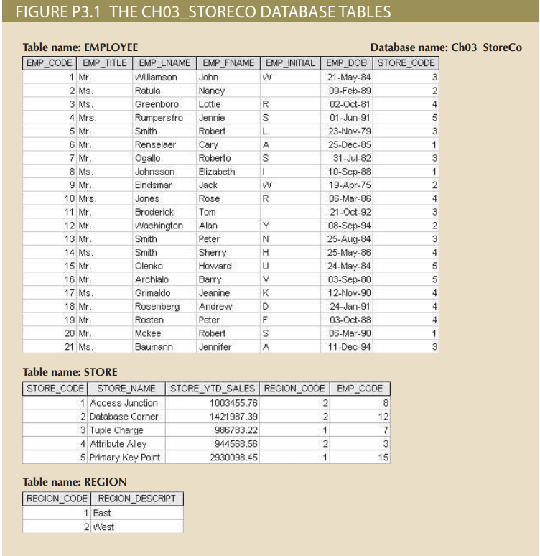

1. For each table, identify the primary key and foreign key(s). If a table does not have a foreign key, write none.

**Answer:** -Table name: - EMPLOYEE

Primary Key: - EMP_CODE, Foreign Key: - STORE_CODE

Table name: - STORE

Primary Key: - STORE_CODE, Foreign Key: - EMP_CODE, REGION_CODE

Table name: - REGION

Primary Key: - REGION_CODE, Foreign key: - None

1. Do the tables exhibit entity integrity? Answer yes or no, and then explain your answer.

**Answer: -** Yes, all the 3 tables exhibit entity integrity. All 3 tables have primary key in the table which will uniquely identify each row. All the primary keys (EMP_CODE, STORE_CODE, REGION_CODE) are unique and no part of a primary key has a null value. Also, the foreign key values are properly referencing the primary key values.

1. Do the tables exhibit referential integrity? Answer yes or no, and then explain your answer

**Answer: -** Yes, the tables exhibit referential integrity. Only REGION table does not have any foreign key in it. But other two tables EMPLOYEE and STORE have foreign key(s) in them. The STORE_CODE column in EMPLOYEE table is a foreign key which is a primary key in STORE table and each row values matches with the values in the primary table. All the values are in the range from 1-5 and nothing more than that. There are no Null values as well. Same goes with the EMP_CODE and REGION_CODE columns in STORE table. They act as foreign key in STORE table. ALL the values match with their respective primary key tables and no Null values exists. No invalid entries in any of the tables.

1. Describe the type(s) of relationship(s) between STORE and REGION.

**Answer: -** The relationship between REGION and STORE is 1:M

We can clearly see that the store and region table are connected via REGION_CODE. We can see from the tables that a Region has many stores operating under it, but a store will fall/ reports to only one region. For example, REGION_CODE 1 that is EAST has two stores under it, which are Tuple Charge and Primary Key Point.

1. Create the ERD to show the relationship between STORE and REGION.

**Answer: -**

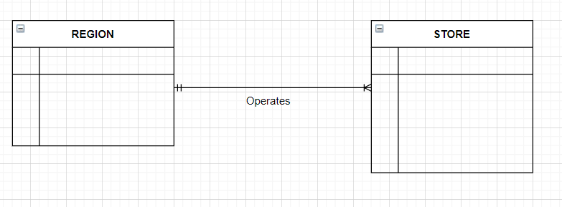

1. Create the relational diagram to show the relationship between STORE and REGION.

**Answer: -**

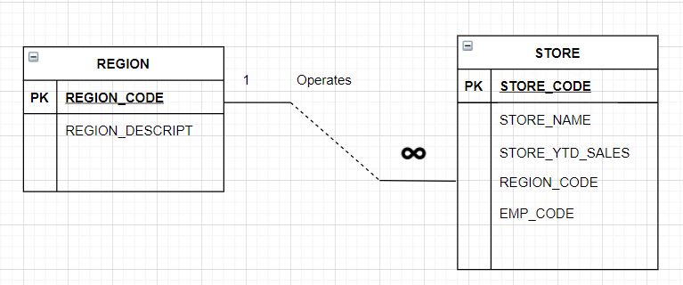

1. Describe the type(s) of relationship(s) between EMPLOYEE and STORE. (Hint: Each store employs many employees, one whom manages the store)

Answer: - There are two relationships between EMPLOYEE and STORE. First one is being the 1: M.

The relation is a store can have many employees working under it, but an employee will be working in only one store so the 1: M relation. Its linked with key STORE_CODE which is a foreign key in the EMPLOYEE table. The second relation is 1:1 relation between the both the tables where only one employee will be managing a store and a store is managed by only one employee so the 1:1 relation. The EMP_CODE is a foreign key in STORE tables which is used for this relation.

1. Create the ERD to show the relationships among EMPLOYEE, STORE, and REGION.

**Answer: -**

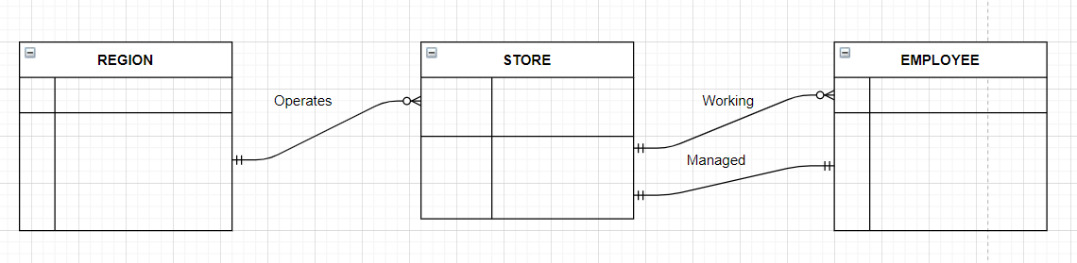

1. Create the relational diagram to show the relationships among EMPLOYEE, STORE, and REGION.

**Answer: -**

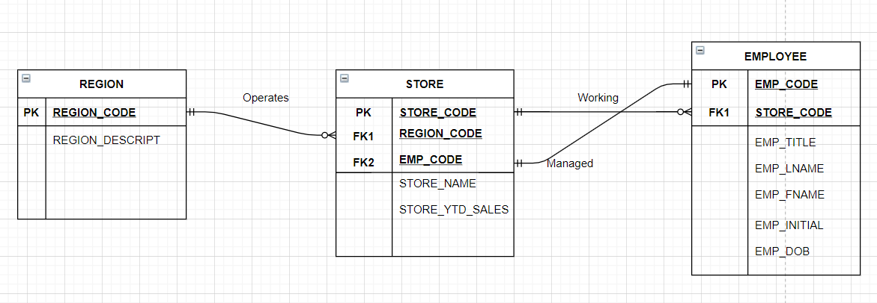

**Note:** Sorry if there is a confusion in the last part of the diagram. Just showing both 1:1 and 1:M relation between STORE and EMPLOYEE. Draw.io allowed only this way so.